Progress Report

**Github Setup**

Signed up to Github and made a public account on Sunny95DMU with the repository CTEC3905_Web_Development_Assignment.

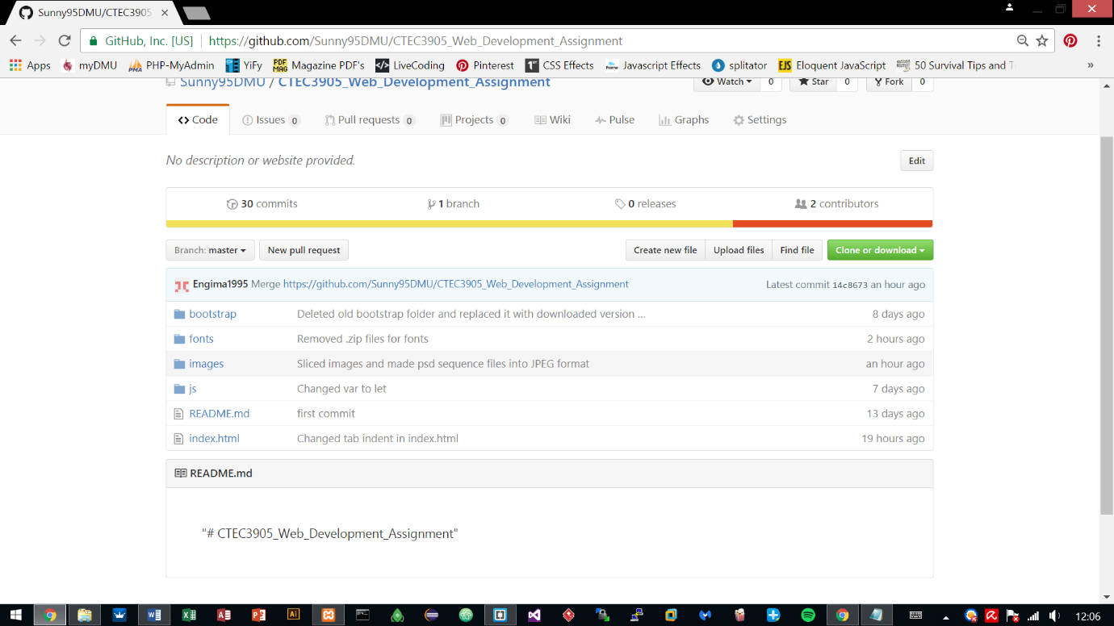

Installed .git local repository for pulling and pushing local work on to the Github repository.

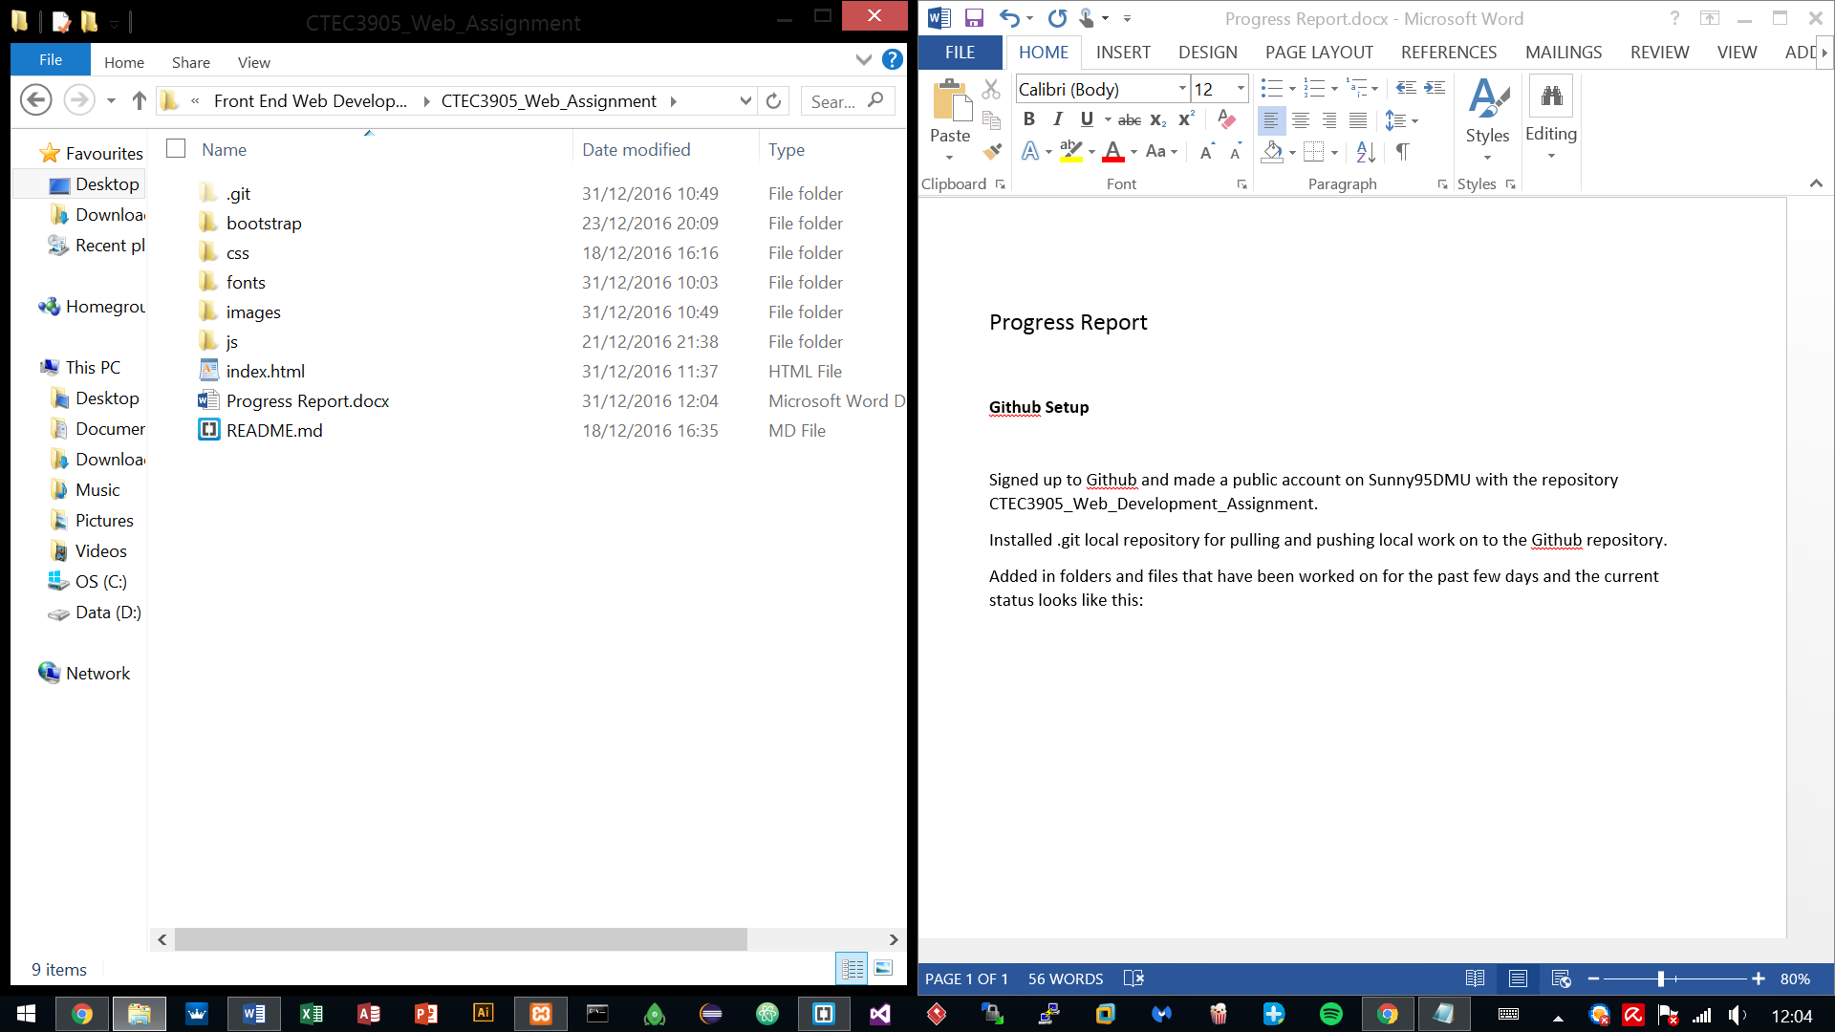Added in folders and files that have been worked on for the past few days and the current status looks like this:

**Fetching Flickr data with JSON**

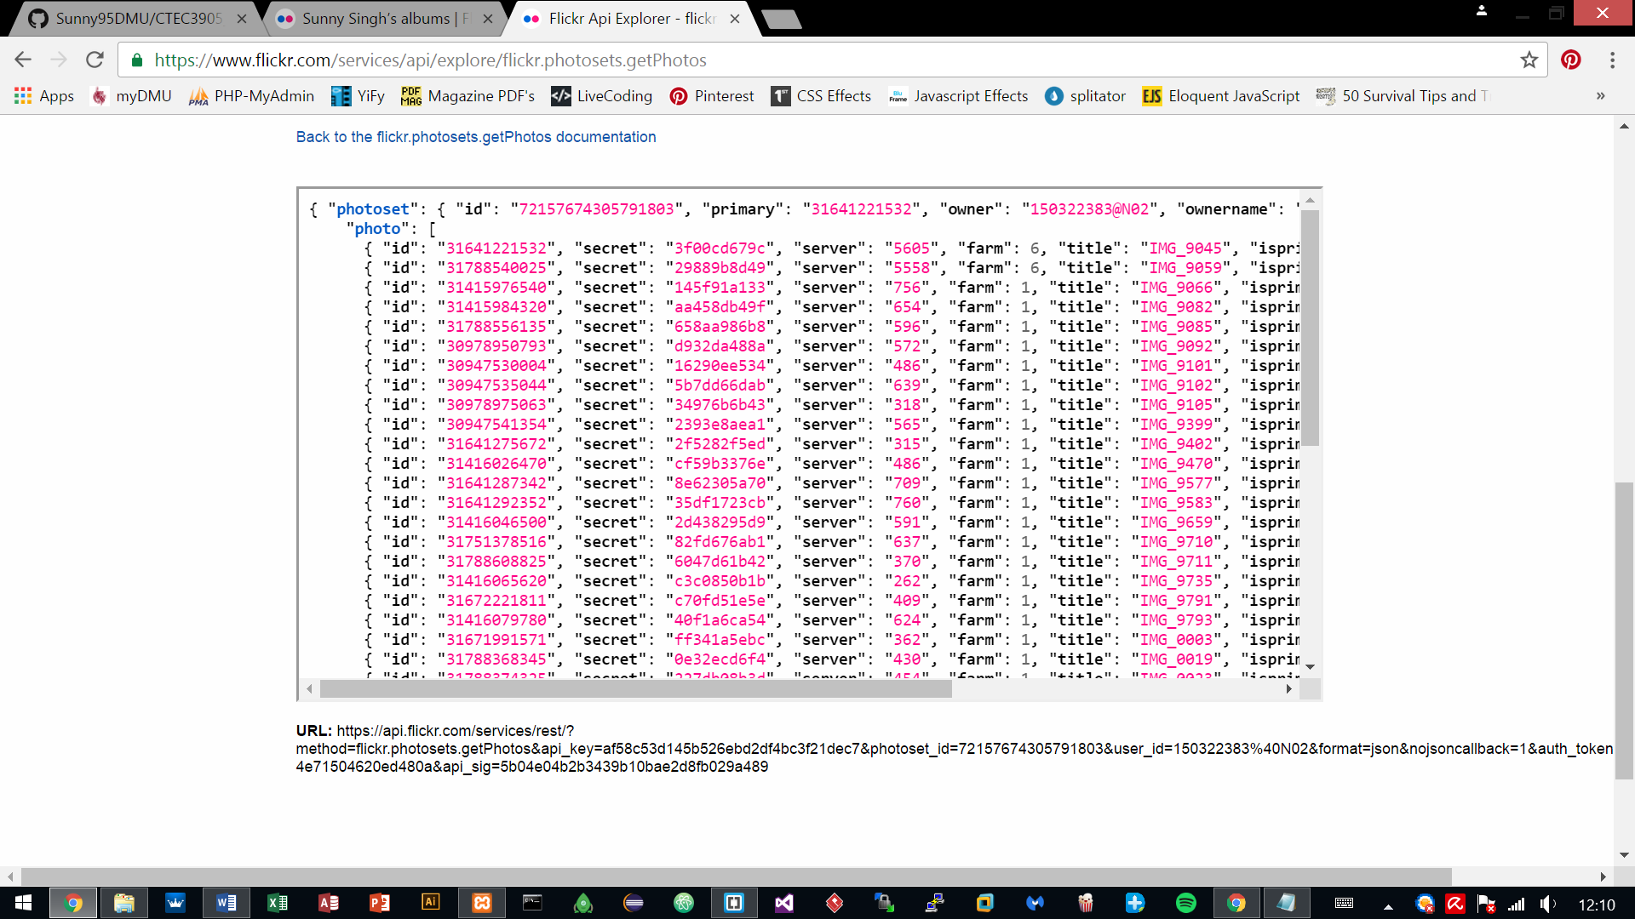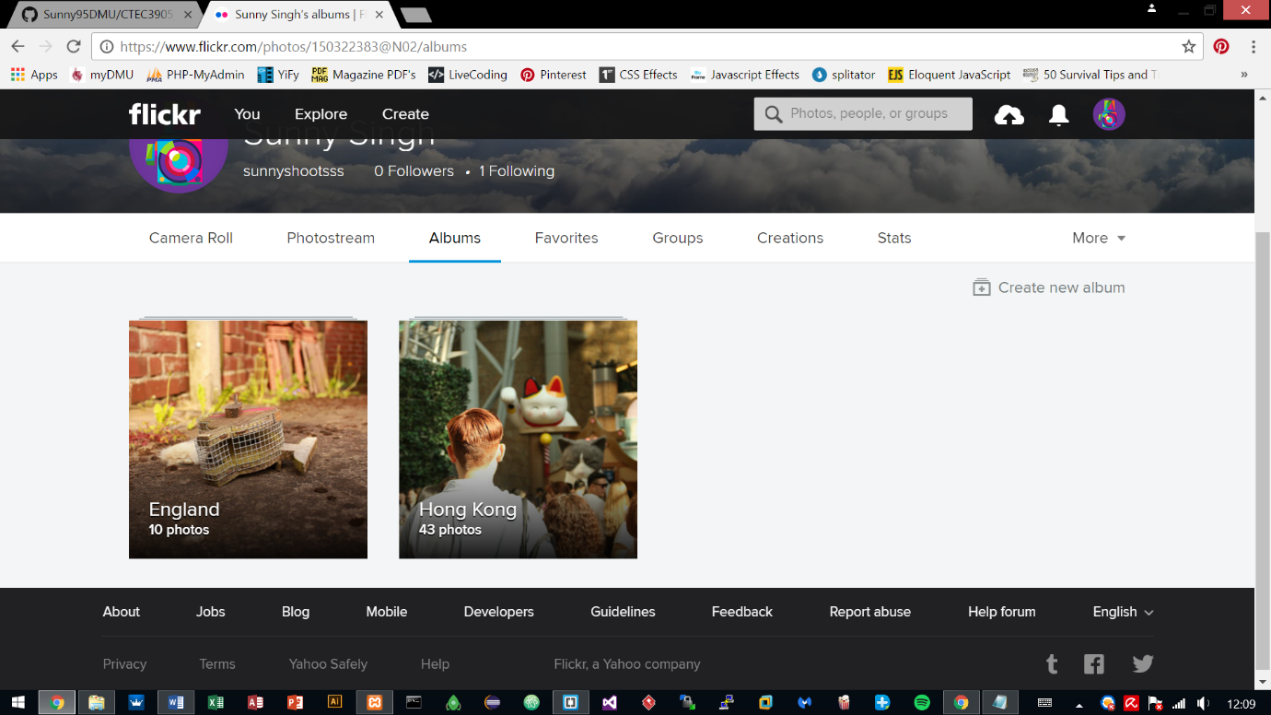Uploaded images to Flickr and used Flickr API to retrieve those uploaded images via JSON, for future use with the development of the site.

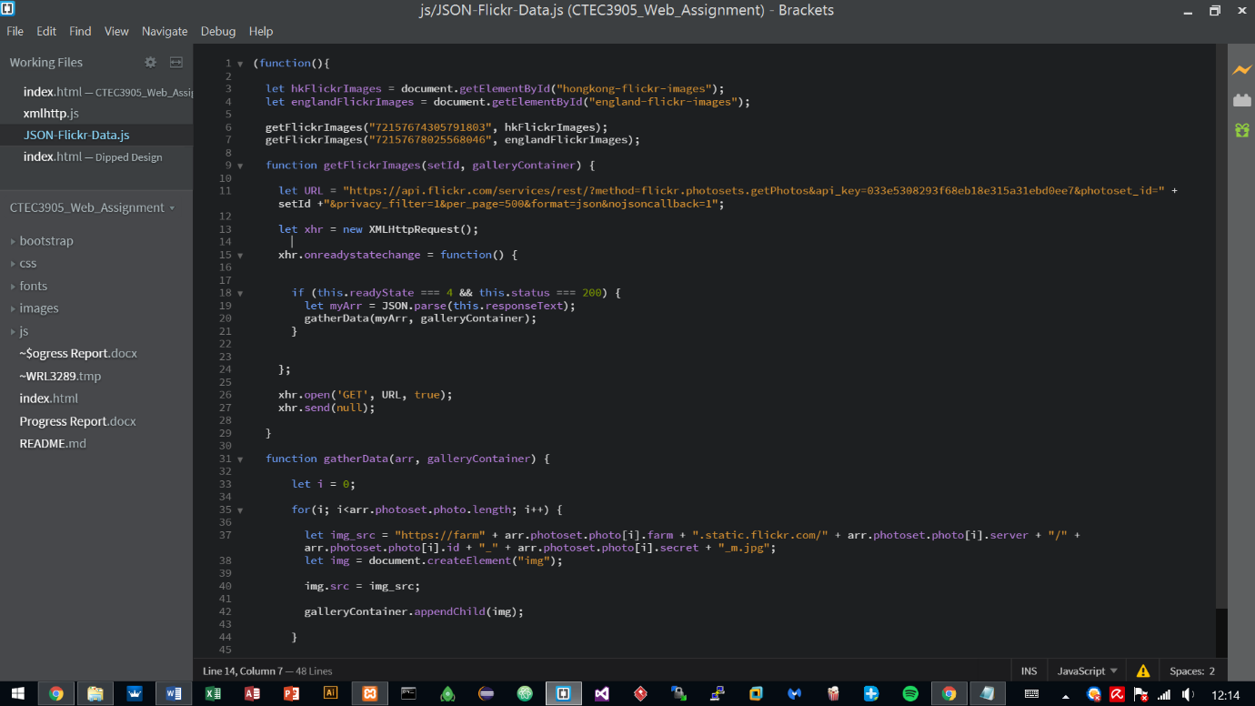Used the API key provided by the Flickr site and used it with JSON for connecting to the server, which in return gave an array of the uploaded images.

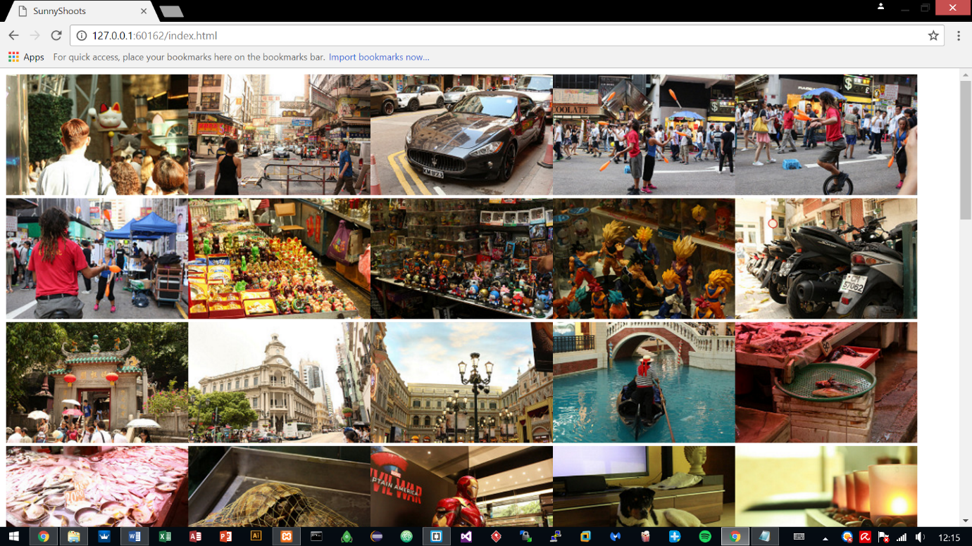

**Created Interface design**

After testing the JSON and the result being successful, it was time to move on to the interface design.

The website is based on a photography portfolio hence why testing the images was important.

The website was done in Photoshop and took 2 days to finish the interface, altogether 8 hours were put into it.

**Sequence 1 – Index Page**

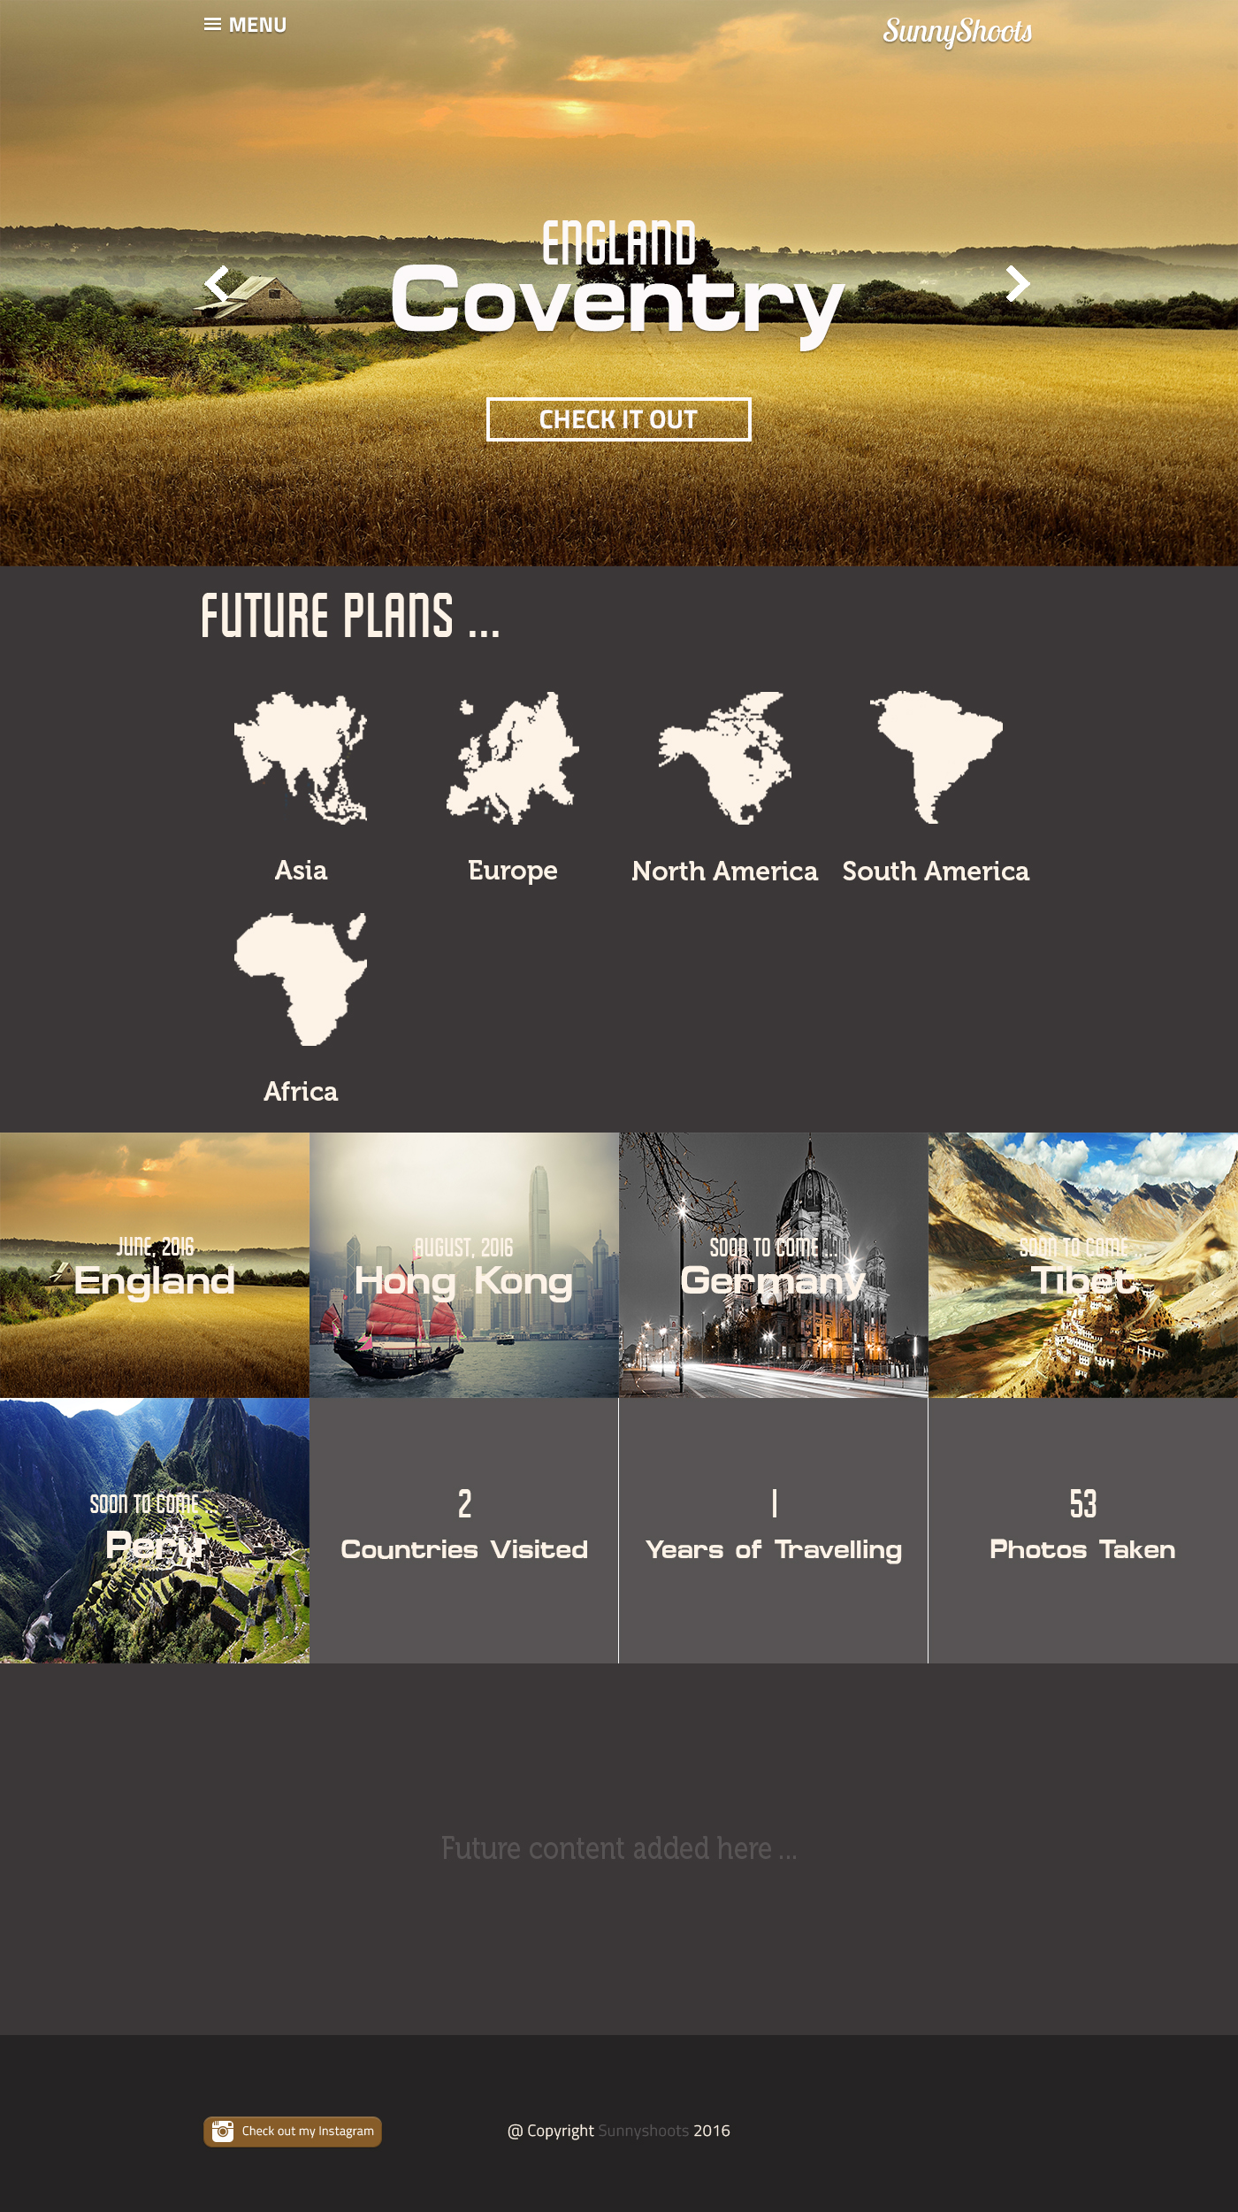

**Sequence 2 – Opening Menu**

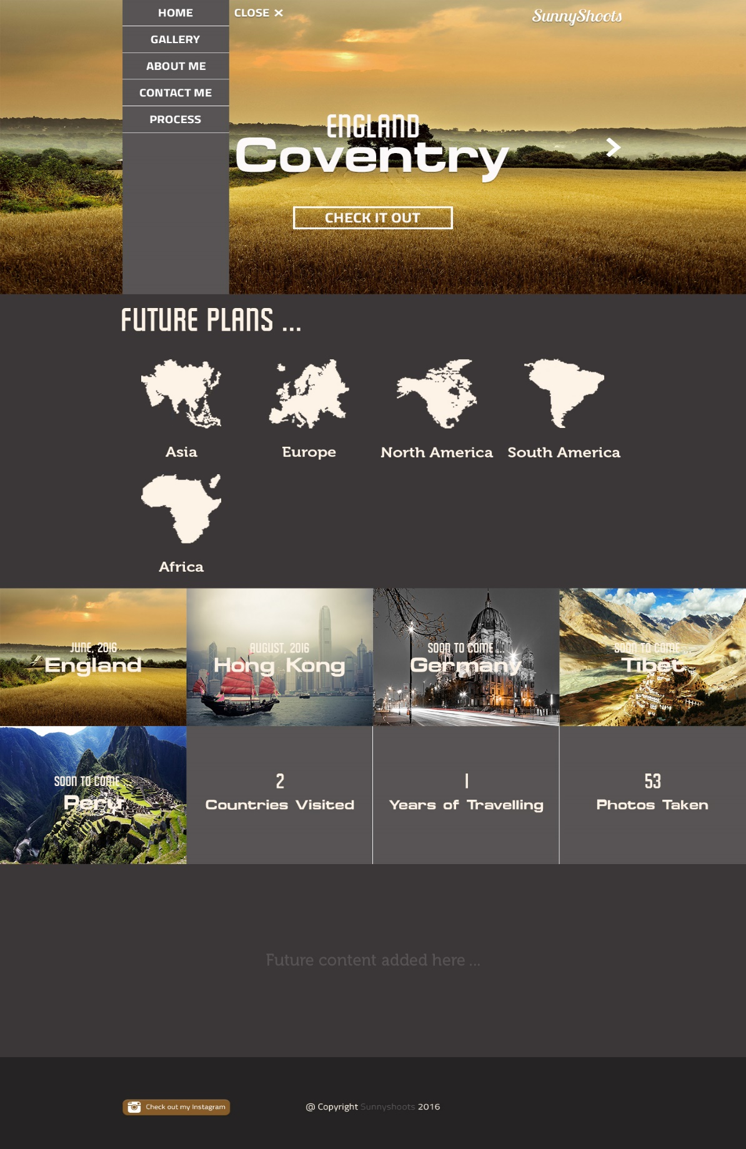

**Sequence 3 – Gallery Tab**

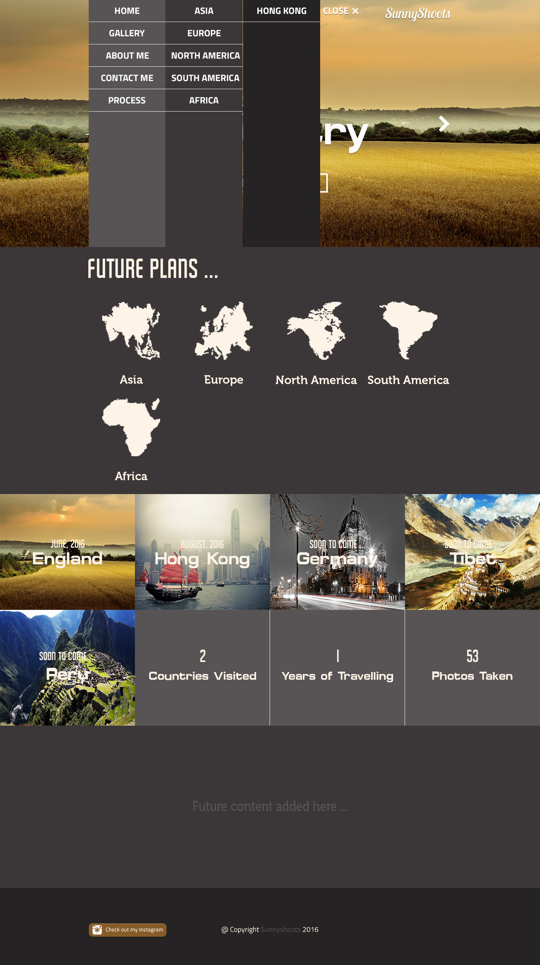

**Sequence 4 – Gallery Page**

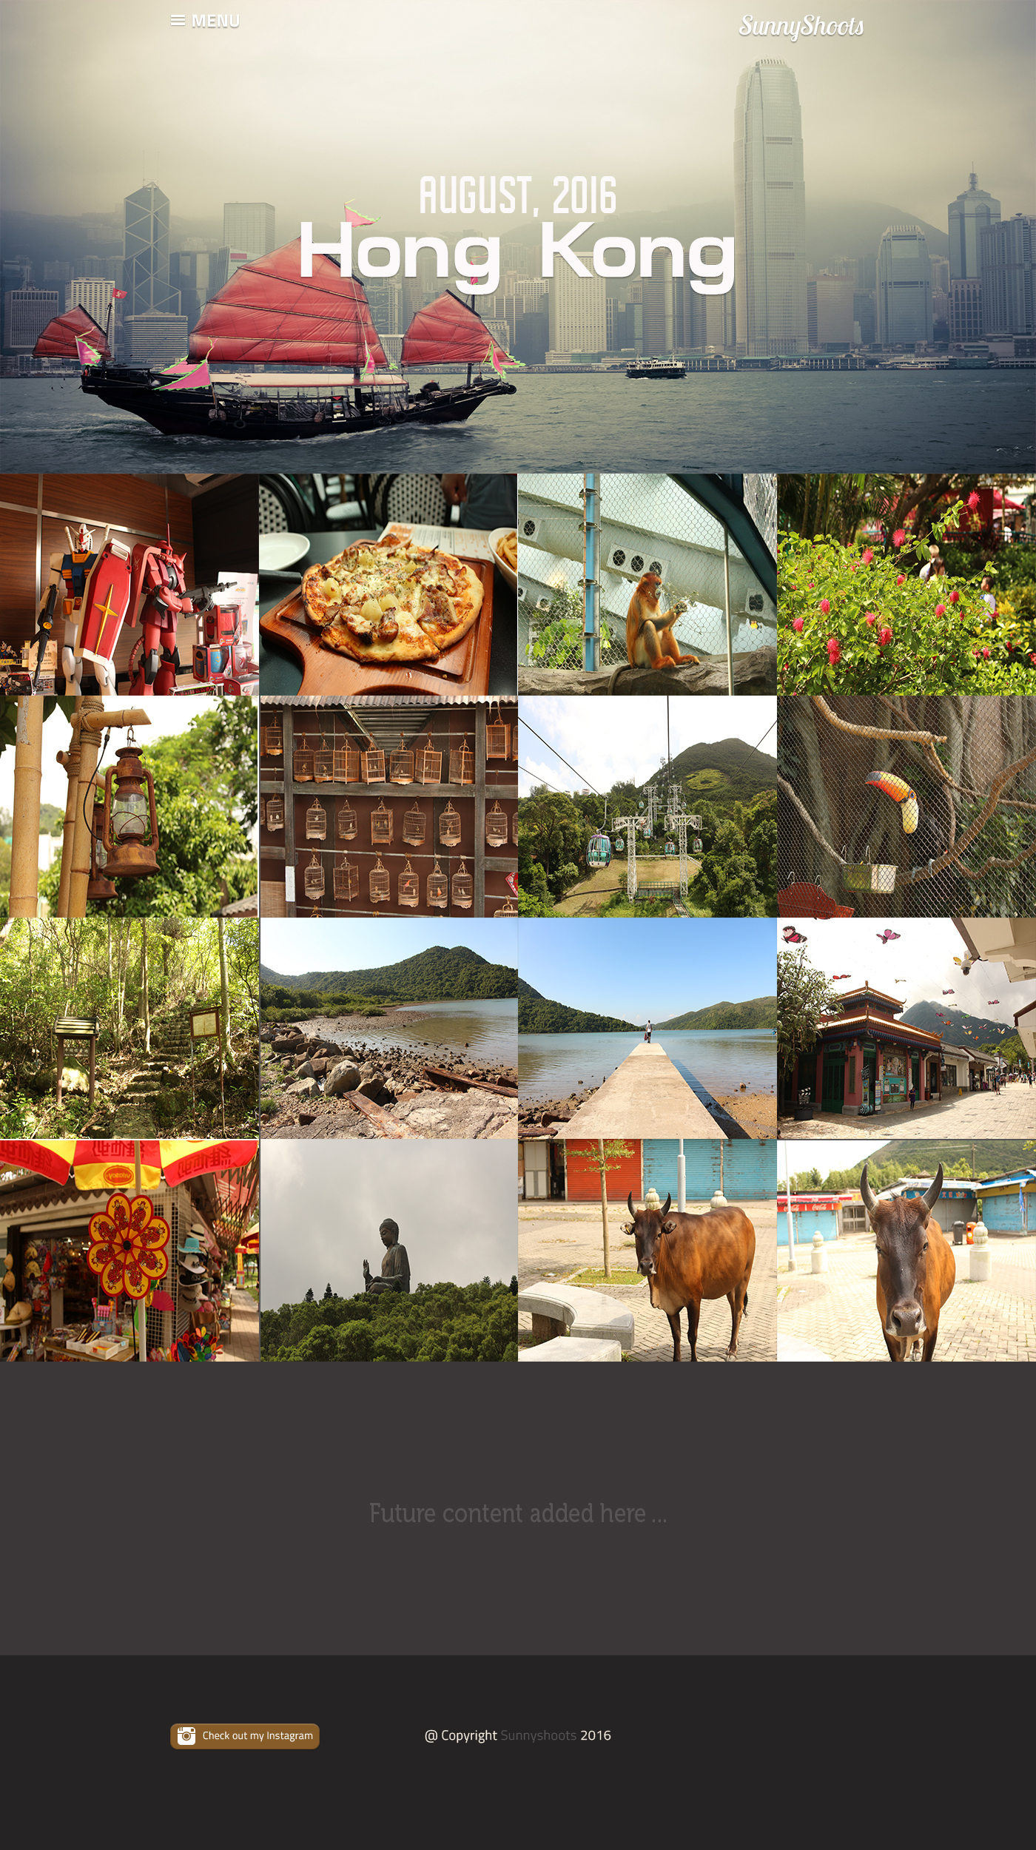

**Sequence 5 – About Me**

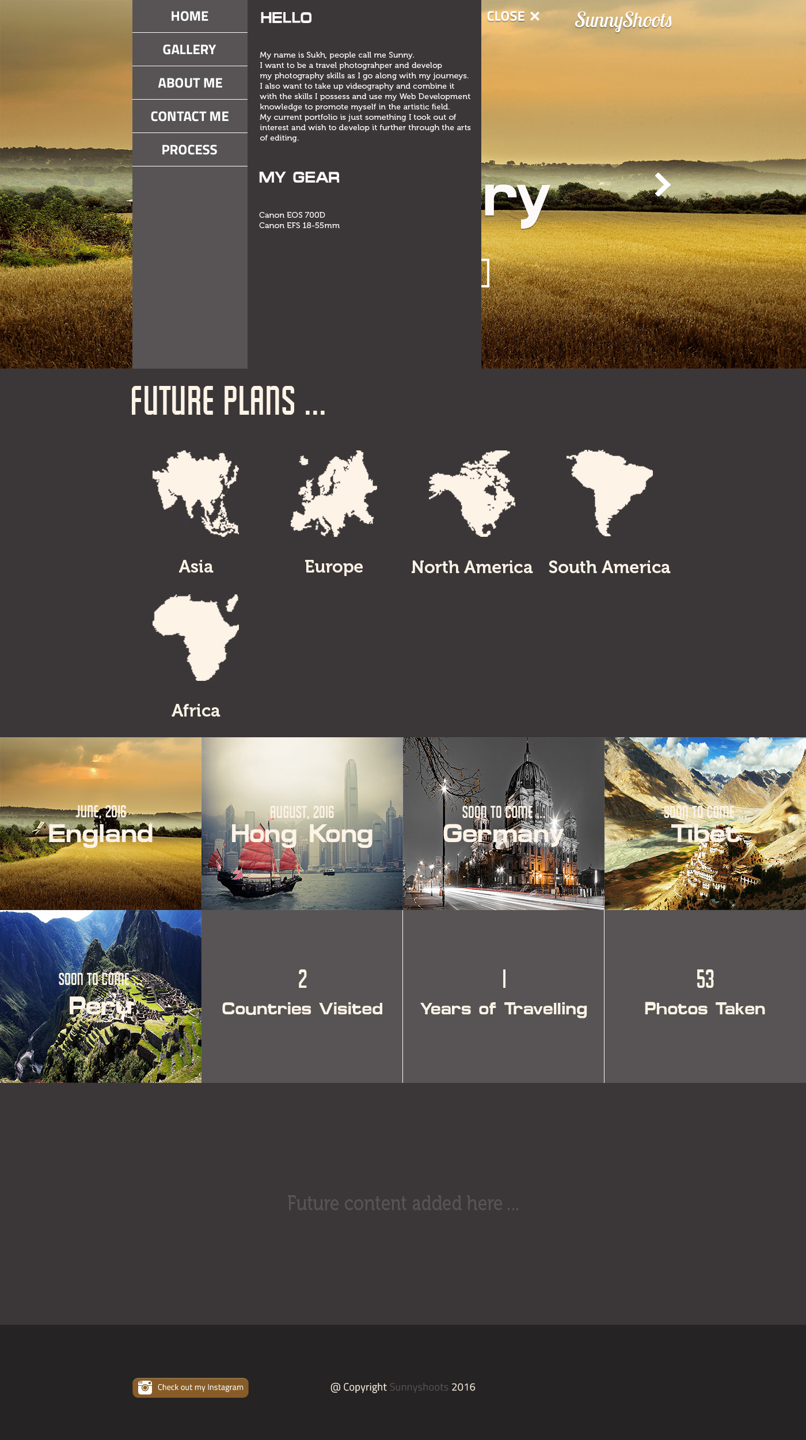

**Sequence 6 – Contact Me**

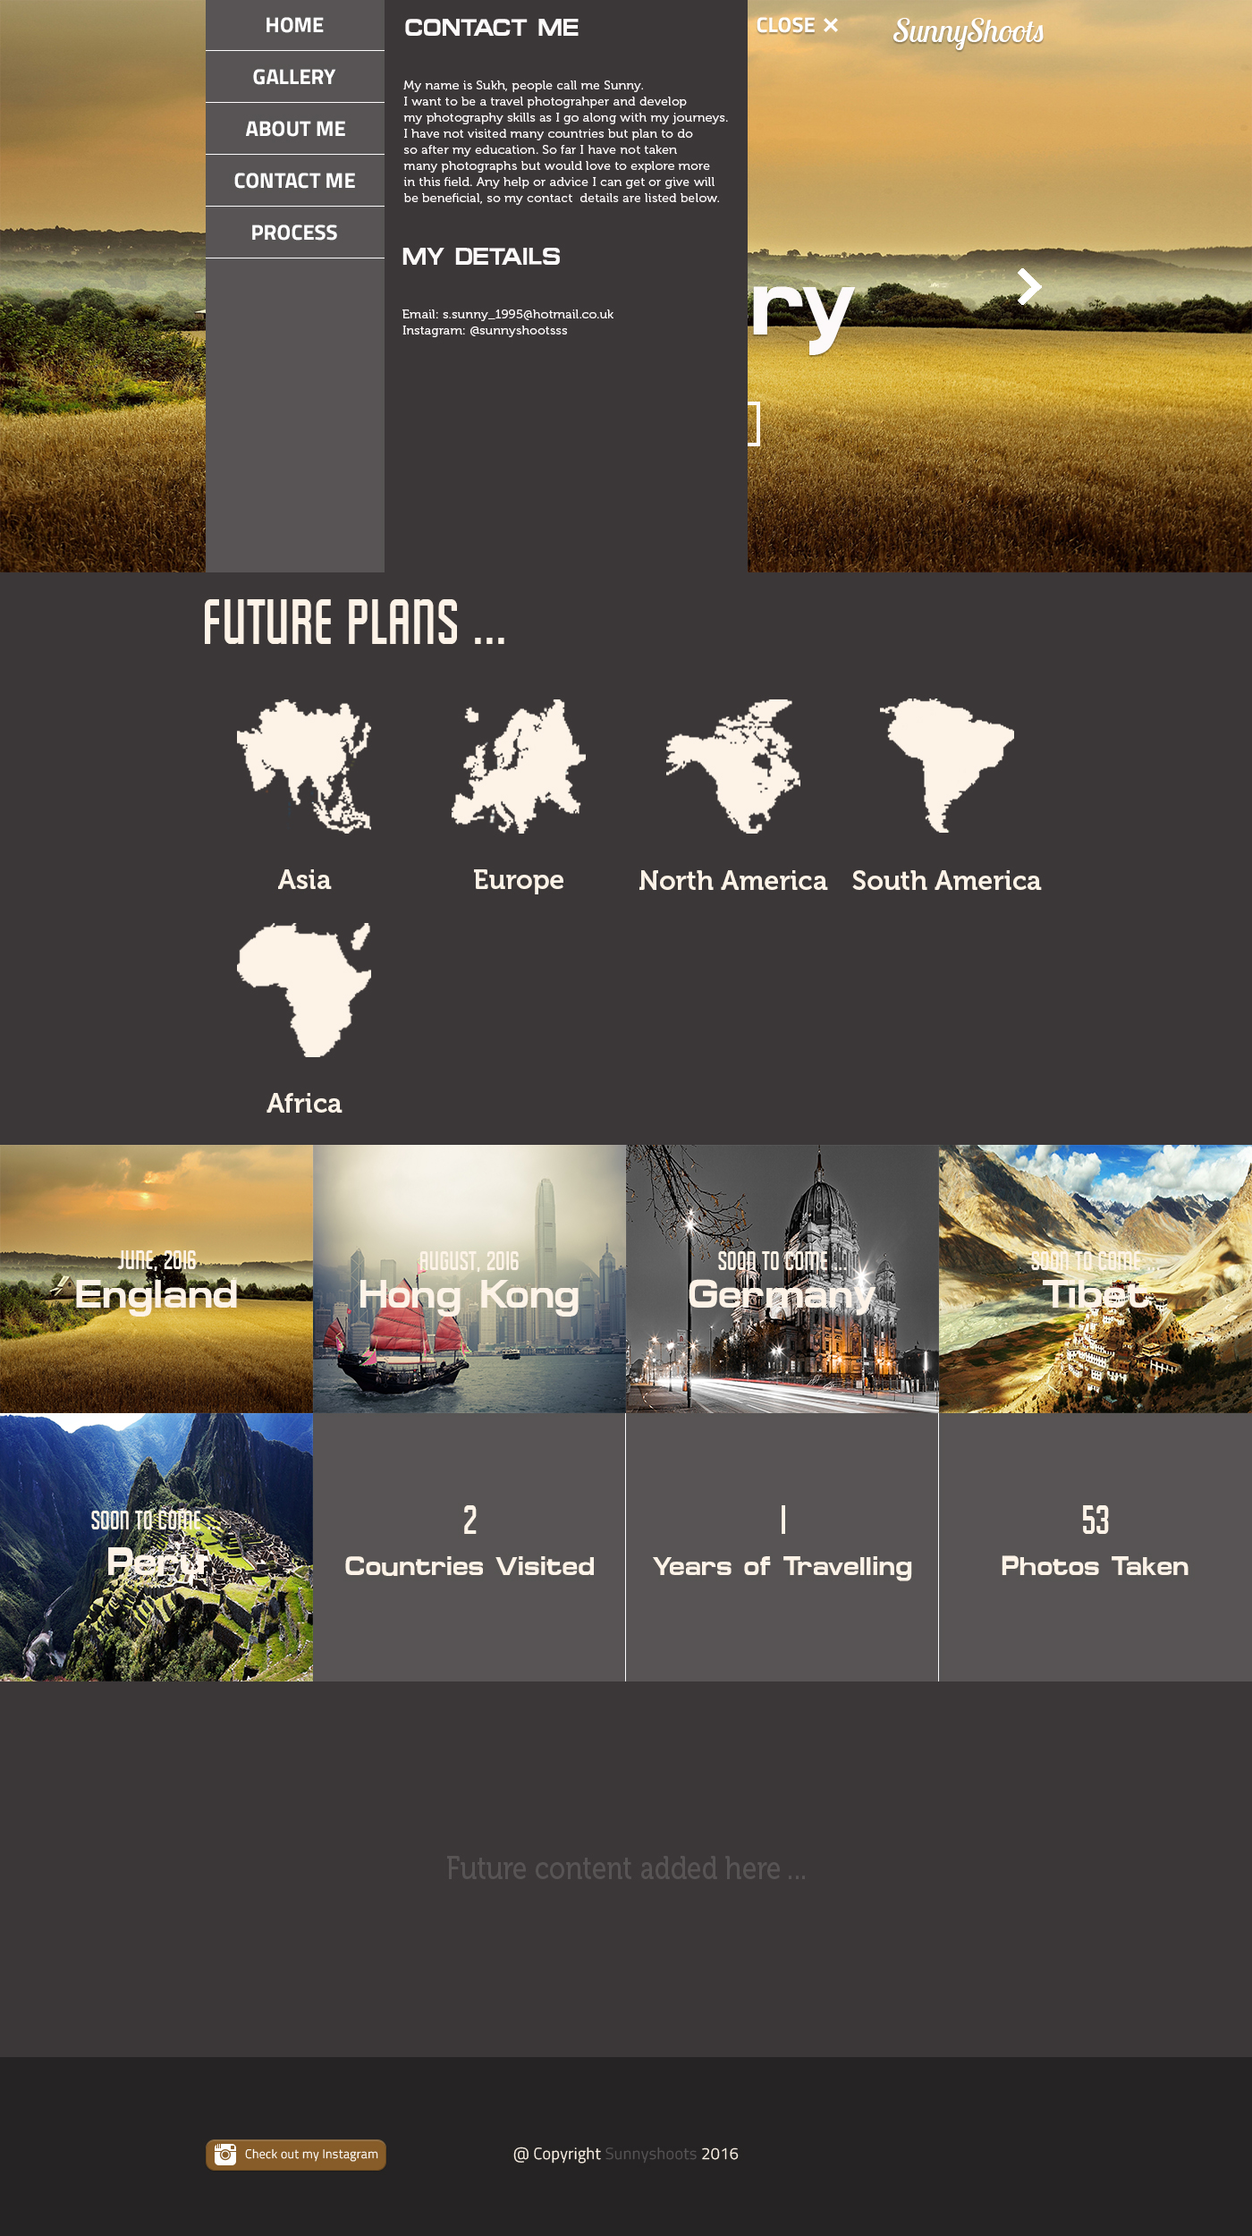

**Started working on index.html**

Index.html is the page that is loaded first. Most likely there are only going to be 3 pages altogether for this demo site: Home page and the Gallery Pages.

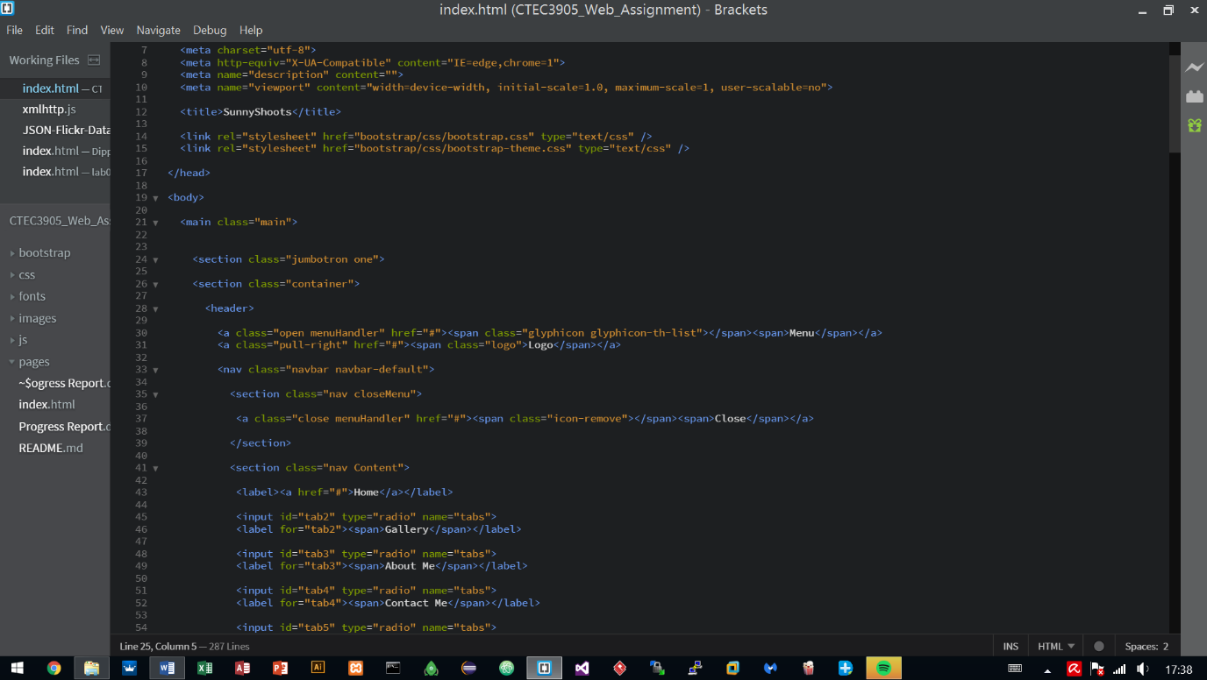Currently started structuring the index.html page using Bootstrap a quick framework to develop the site. The reason for this is, Bootstrap has been utilised before in other projects and has proven to work well as well as providing quick results so other areas could be looked at earlier on such as using animations and JavaScript to handle parts of the site.

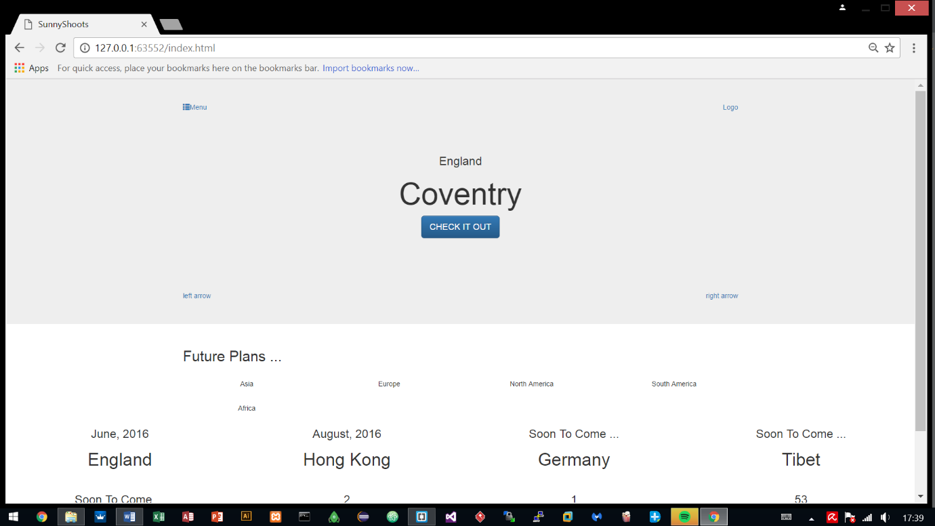

**Added two more pages – hongkong.html and england.html**

After working on the index.html, two more pages were added which are the gallery pages, displaying photographs of the places that were visited and the pages are titled according to the countries/cities visited.

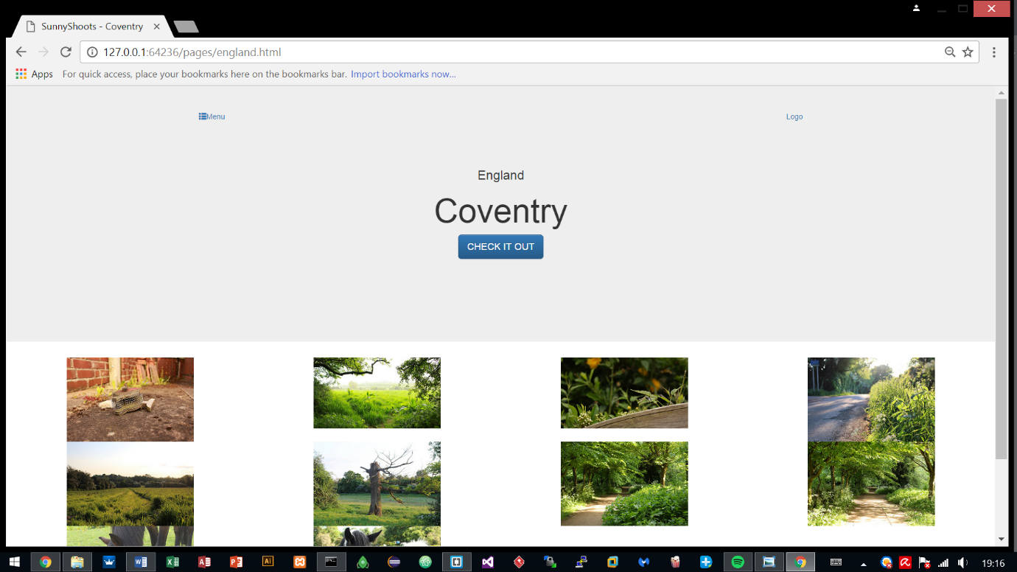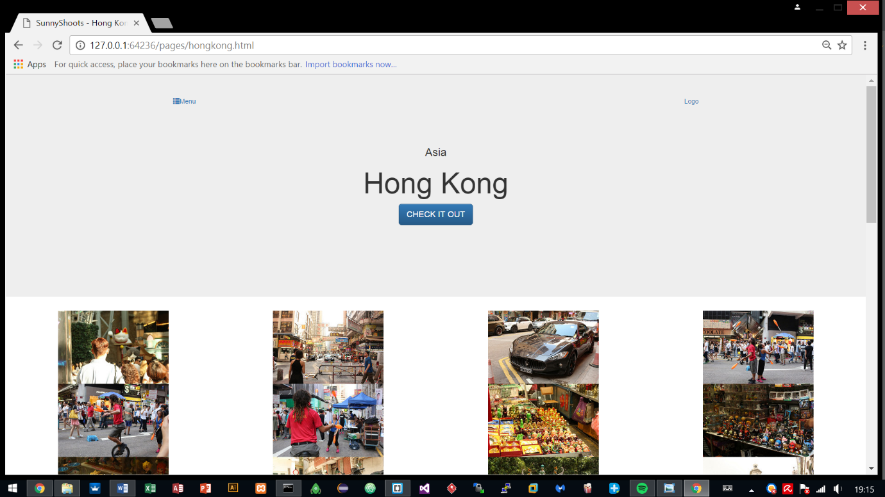The syntax for both pages have a similar layout compared with the index.html so most of it was just copied towards these html files and was edited. The two pages share the exact same syntax, only required changing of the class names.

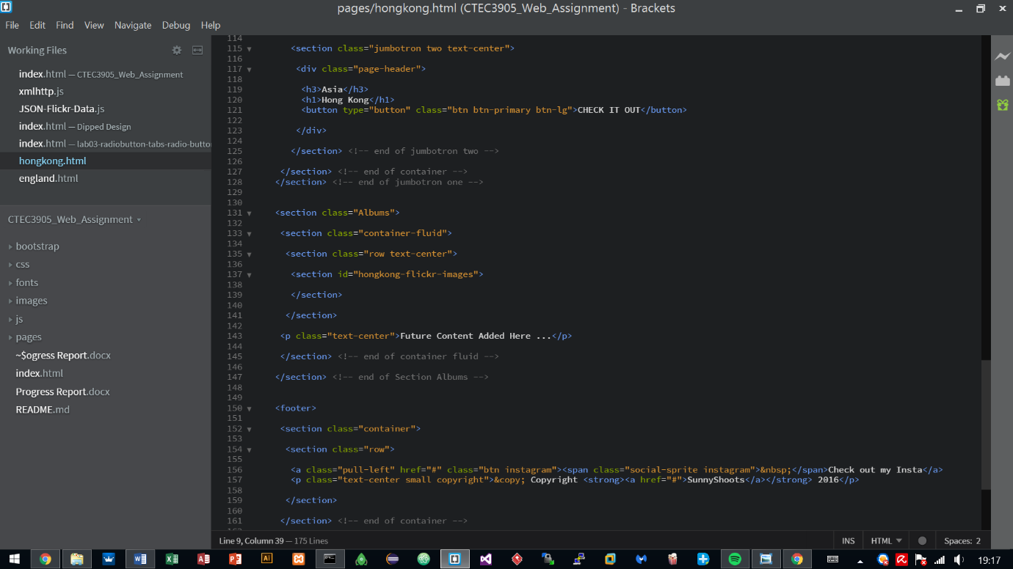

**Current Progress – Styling**

Styling has been started and has been done on the 1st and 2nd parts, other parts are still in progress.

The fonts and logos have been initialised to what the interface designs show and currently just working on finishing the styling so later on it can be using some interactive features using animations and Javascript.

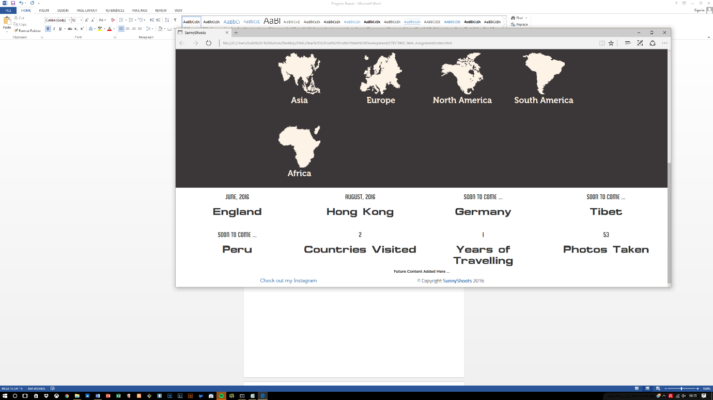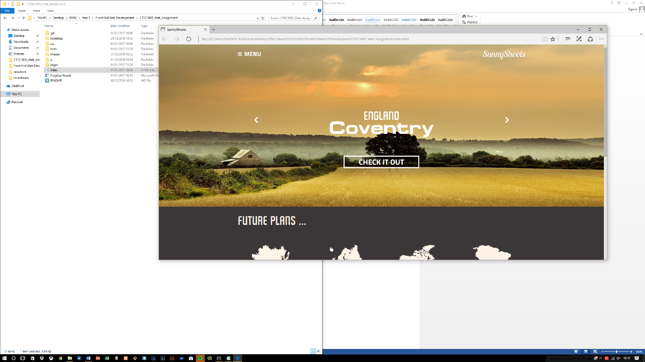

Two CSS stylesheets are being utilized that have been created by me, the rest is what Bootstrap provides by default.

Font.css sets up the font families that can be utilized within the development of the site and the style.css works by changing what bootstrap provides to suit to the interface design.

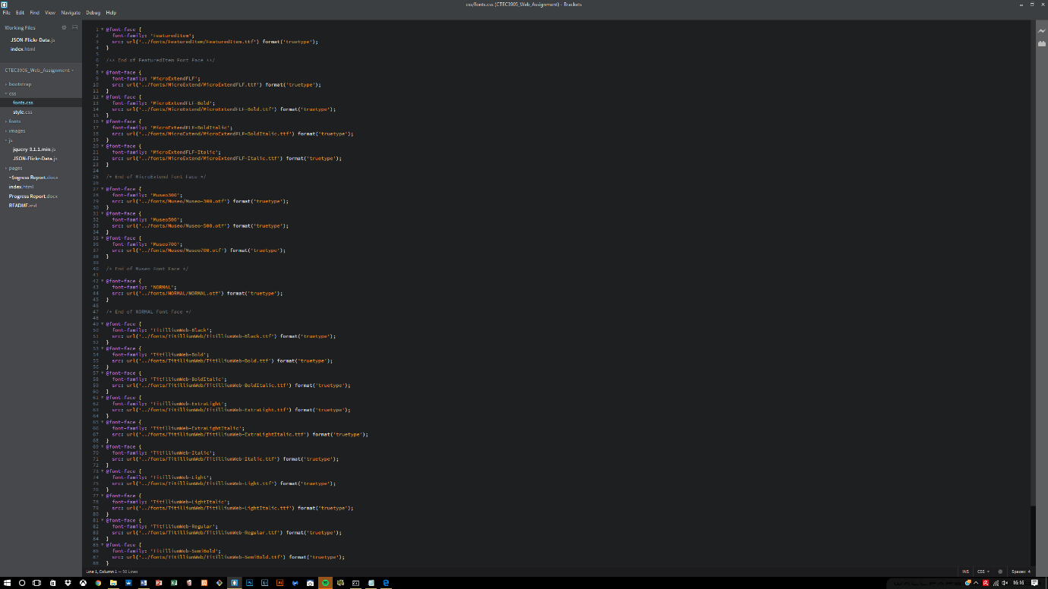

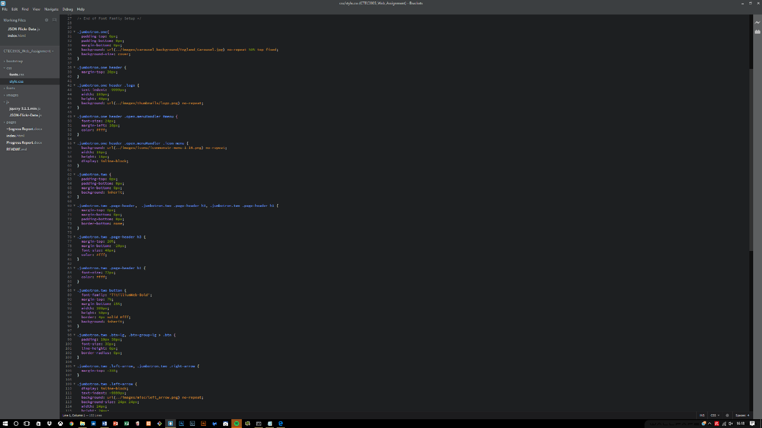

**Errors encountered within the first section**

Whilst developing, I soon realised that the structure of the semantics was not correct. The menu header was inside a container which held other main containers which should not have been there.

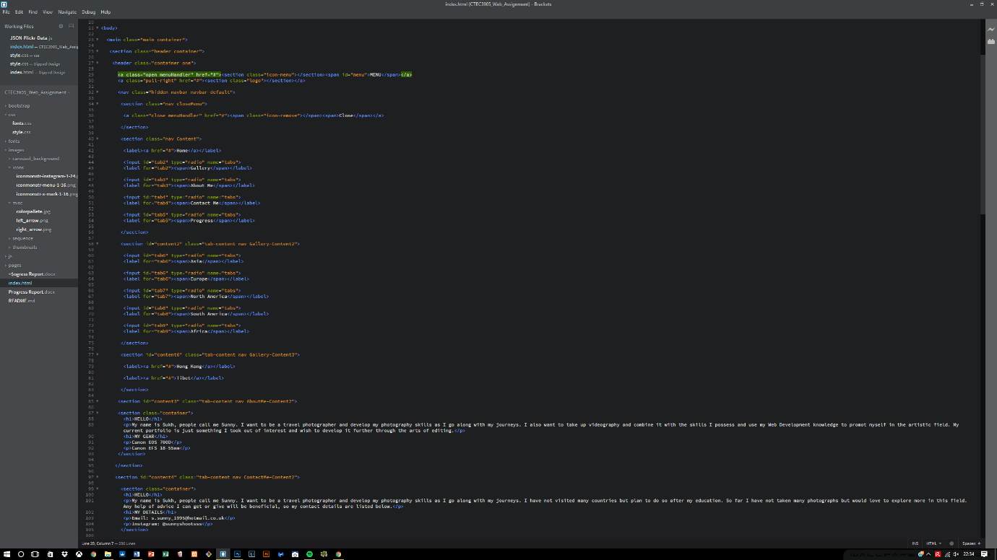Therefore the entire process took a lot of time due to rearranging of the structure and now the structure is working fine, the menu header is fixed and separated from the other content within the container. There is now the main container holding the entire site, and different containers holding relevant content.

